Q1. Write a query to display all users stored in the system.
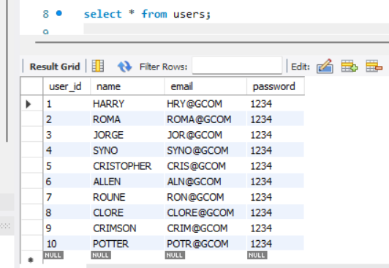

Q2. Write a query to list all movies in the movie table.
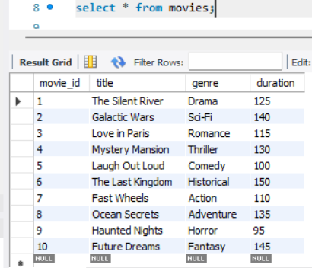

Q3. Write a query to display all available shows.
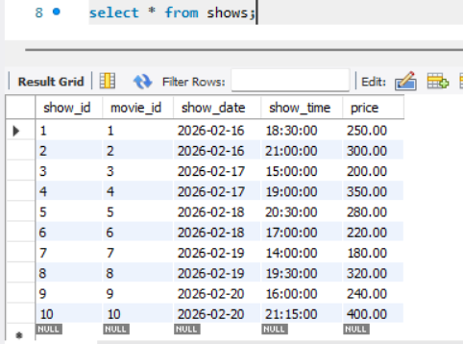

Q4. Write a query to fetch details of a movie using its movie_id.
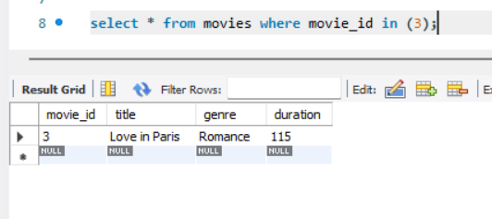
Q5. Write a query to list all shows of a particular movie.
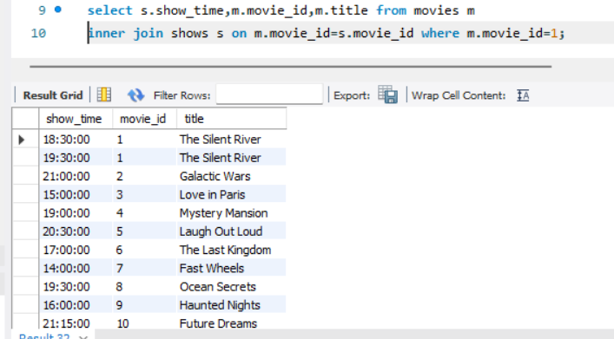

Q6. Write a query to list all seat numbers from the seats table.
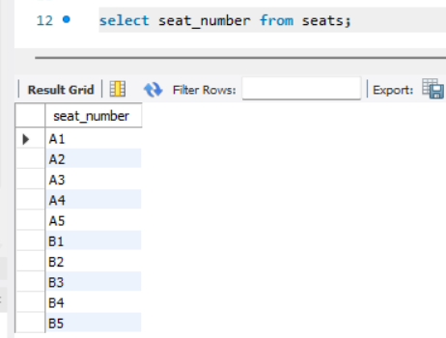
Q7. Write a query to find available seats for a specific show.
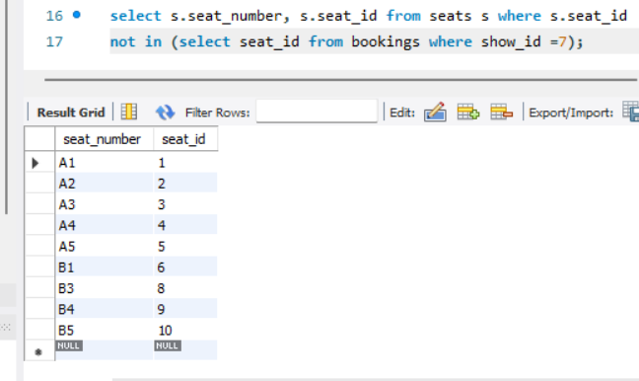
Q8. Write a query to display all booked seats for a specific show.
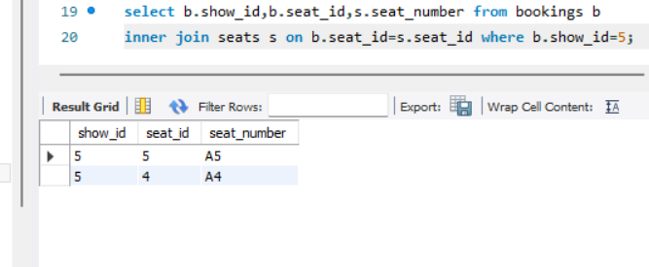
Q9. Write a query to insert a new user into the users table.
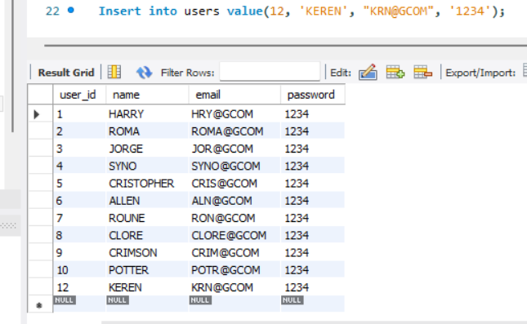

Q10. Write a query to insert a new movie into the movies table.
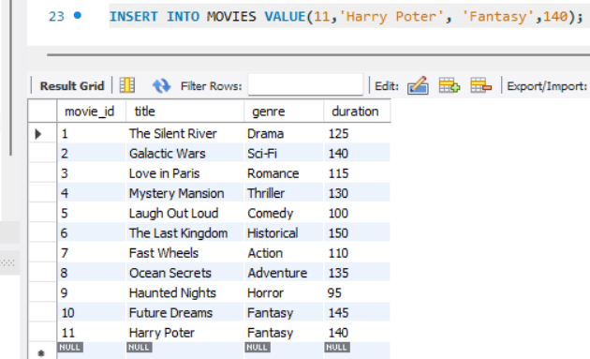
Q11. Write a query to insert a new show into the shows table.
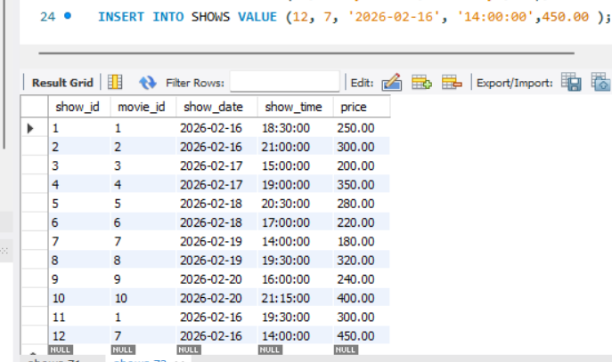
Q12. Write a query to add a new seat to the seats table.
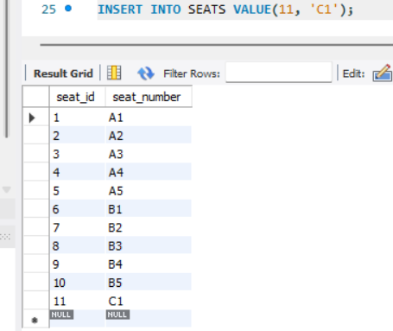
Q13. Write a query to book a ticket for a user.
INSERT INTO BOOKINGS VALUE (12,3,8,2,'2026-02-17 14:20:00');
Q14. Write a query to display all bookings
SELECT b.booking_id,
b.show_id,
b.seat_id,
m.movie_id,
m.title,
s.seat_number,
sh.price,
sh.show_time
FROM bookings b
JOIN shows sh
ON sh.show_id = b.show_id
JOIN movies m
ON sh.movie_id = m.movie_id
JOIN seats s
ON b.seat_id = s.seat_id;
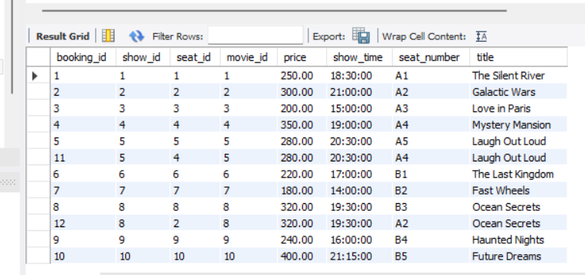
Q15. Write a query to display booking history for a specific user.
SELECT b.user_id,b.booking_id,b.show_id,b.seat_id,m.movie_id,sh.price,sh.show_time,s.seat_number,m.title from bookings b
join shows sh on sh.show_id=b.show_id join movies m on sh.movie_id=m.movie_id join seats s on b.seat_id = s.seat_id where b.user_id=3;

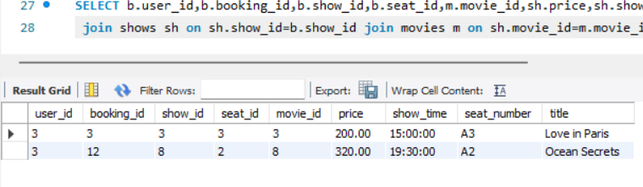
Q16. Write a query to count total bookings for a specific show.
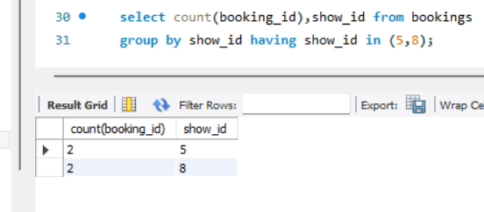
Q17. Write a query to count total bookings for a specific movie.
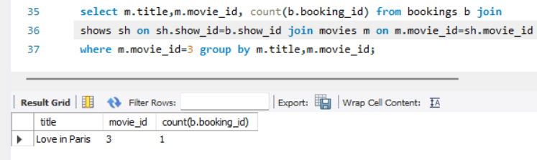
Q18. Write a query to find all movies of a specific genre.
select genre,movie_id,title from movies where genre='fantasy';

Q19.Write a query to update the duration of a movie.
update movies set duration=120 where movie_id=5;

Q20. Write a query to update the seat number for a given seat_id.
update seats set seat_number='B3' where seat_id=4;
Q21. Write a query to delete a specific booking record.
delete from bookings where booking_id=3;
Q22. Write a query to delete a movie from the movies table.
Q23. Write a query to list movies longer than 2 hours.
select title, duration from movies where duration>=120;
Q24. Write a query to find shows scheduled for today's date.
select * from shows where show_date=current_date();
Q25. Write a query to list upcoming shows sorted by date and time.
select * from shows where show_id>=current_date() order by show_date asc , show_time asc;

